Paula De Francisco Pérez  Growth · Channel Experiments · Marketplaces · AI-First  Dubai, UAE | +971 50 386 3656 | paulich98@hotmail.com  linkedin.com/in/paula-de-francisco-perez-92a13119a  Portfolio: paula-de-francisco.vercel.app  Nationality: Spanish | UAE Employment Visa (employer-sponsored) | 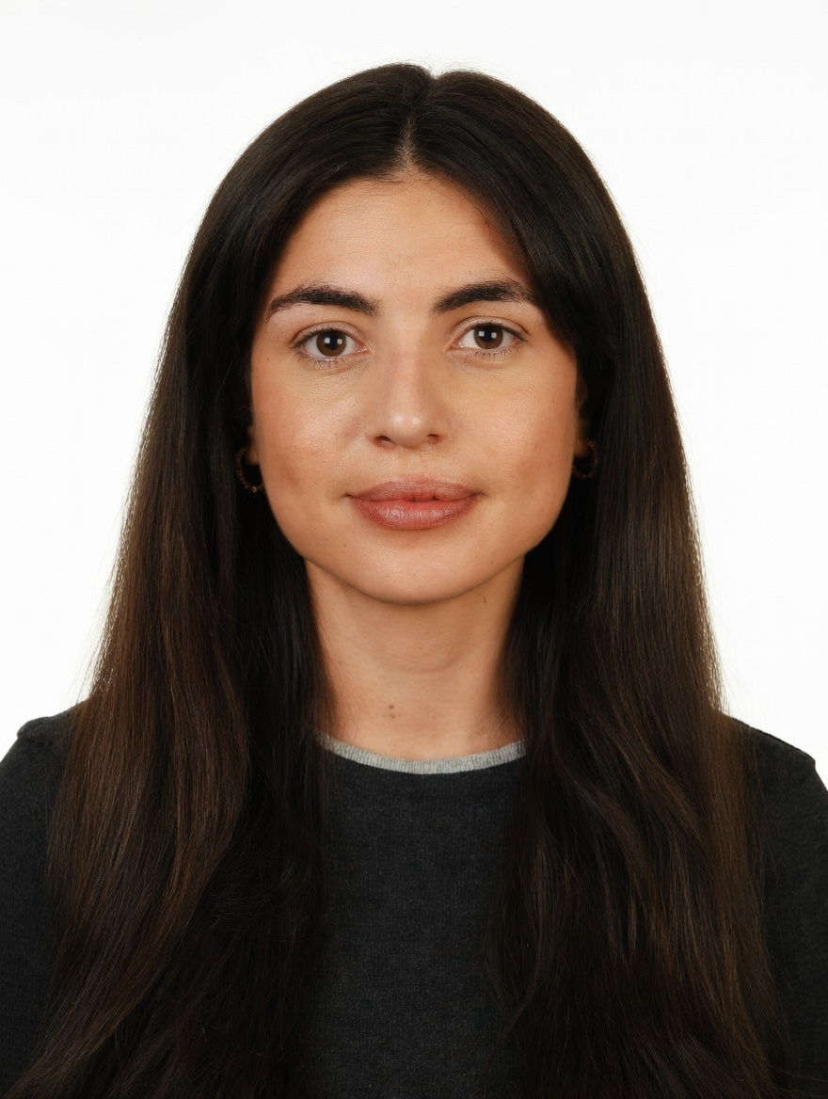
PROFESSIONAL SUMMARY

Hands-on growth marketer who builds channels from zero and tests them against a control. At DoFreeze: an influencer channel to 103 creator activations, an affiliate programme, communities and Meta Advantage+, all judged on incremental sales. Before that, worked the supply side of two marketplaces: 30+ new sellers and 42 brands at Alibaba's Miravia, XL accounts at Glovo.
WORK EXPERIENCE

Brand & Marketing Manager | Oct 2025 – Present
DoFreeze LLC · UAE F&B / FMCG group | 7 brands incl. Befit, Eurocake, SMASH | sold on talabat, Noon, Careem · Dubai, UAE
• Built channels from zero: influencer programme to 103 creator activations over 3 waves at AED 81 per content piece; Befit Crew affiliate programme (personal codes, tiered commissions); running, padel and yoga communities
• Tests that settle arguments: the SMASH x talabat giveaway lifted daily sales +165% vs +4.7% for a control brand; weekly creative-hook tests; a giveaway added followers at AED 0.73 each, 8x cheaper than a promoted reel
• Scale or stop on unit economics: computed break-even ROAS per brand and channel net of marketplace fees and moved Google spend to Meta; built an Advantage+ retargeting campaign at 3.7x ROAS in week one
• Conversion, not just traffic: web orders +86% and revenue +57% (Q1 vs Jun–Aug 2026) after reviews, bundles rebuilt from basket analysis and a 30-day replenishment flow; segmented a 16K email base
• Build it hands-on: a Claude-based system automating campaign planning, content and KPI reporting (~40% less manual work), landing pages built with AI agents; brief a designer and a social media exec
Key Account Manager – Beauty, Fragrances & Fashion | Nov 2023 – Oct 2025
Miravia & AliExpress (Alibaba Group) · Two-sided marketplace | Beauty & Health department · Madrid, Spain
• Supply-side growth: spotted the Arabian-perfume trend and onboarded 30+ sellers in two months (incl. Lattafa and Arabian Oud distributors), making it a top-growing sub-category
• Grew 42 beauty and fragrance brands (incl. L'Oréal Paris, Maybelline, NYX, Redken, KIKO Milano) +30% GMV QoQ via pricing, promotions and on-site visibility; worked with marketing, product and ops
Account Manager – XL Accounts | Sep 2022 – Nov 2023
Glovo · Three-sided delivery marketplace | 10K+ employees · Madrid, Spain
• Co-managed 5 XL restaurant accounts (KFC, Taco Bell, Vicio) on GMV, orders, promo spend and in-app ads; read campaign returns to pick activation days
Early Career | 2019 – 2022
Mondelez International · Línea Directa Aseguradora · Global FMCG | Spanish direct insurer · Madrid, Spain
• Category Planning Trainee, Mondelez (Aug 2021 – Aug 2022): sell-in/sell-out and promo-effectiveness analysis, NPD support
• Accounting Intern, Línea Directa (Jan – Dec 2019): accounting department of an insurer, working in SAP and Looker
CORE SKILLS & TOOLS

Growth Channels | influencer, affiliates & referral, communities, paid social & search, email & lifecycle, marketplaces
Conversion & Build | Shopify, CRO, AI-built landing pages, bundles, reviews, email flows, Meta & Google Ads
Experimentation | control-group tests, creative testing, break-even ROAS, unit economics, scale-or-stop decisions
Data & Analytics | ROAS, CPA, CTR, CVR, AOV, incrementality, basket analysis, Looker, Power BI, Excel (Expert)
AI & Tools | Claude / Claude Code (agents, automation, dashboards), ChatGPT, Canva, Photoshop
EDUCATION

Bachelor's in Business Administration — CUNEF Universidad, Madrid | 2016 – 2020
Specialisation: E-Commerce · Fashion Industry · Thesis on e-commerce in fashion retail (9.5/10)
Google E-Commerce Certificate · Google Digital Marketing Certificate
LANGUAGES

Spanish | Native | English | Professional C1

